VIT BHOPAL UNIVERSITY
FUNDAMENTALS IN AI & ML
Project Report
AI Career & Course Recommendation System

PRAJJWAL PANDEY 25BAI11515

🔹 1. ABSTRACT
This project presents an AI-based Career and Course Recommendation System developed using a rule-based approach. The system helps users select suitable career paths based on their interests and skills such as mathematical ability, communication, and creativity.
The system simulates an expert decision-making process using predefined rules and knowledge representation. It provides not only career suggestions, but also relevant courses required to achieve those careers.
The application is built using Python and Tkinter, offering a user-friendly graphical interface. The system covers multiple domains including technology, business, healthcare, agriculture, and more, making it practical and scalable.

🔹 2. INTRODUCTION
Artificial Intelligence (AI) is the simulation of human intelligence in machines. One important branch of AI is Expert Systems, which use knowledge and rules to make decisions similar to human experts.
Choosing a career is one of the most important decisions in a student’s life. Many students face confusion due to lack of proper guidance. This project aims to solve this problem by developing a rule-based recommendation system.
The system analyzes user inputs and suggests suitable careers along with courses, making the decision process easier and more structured.
🔹 3. PROBLEM STATEMENT
Students often face difficulty in choosing the right career path due to:
- Lack of proper guidance
- Confusion about interests and skills
- Limited access to career counseling
This project aims to develop a system that:
- Provides career recommendations
- Suggests relevant courses
- Uses logical decision-making

🔹 4. OBJECTIVES
The main objectives of this project are:
- To design a rule-based AI system
- To recommend careers based on user inputs
- To suggest courses required for selected careers
- To create a user-friendly graphical interface
- To apply AI concepts like knowledge representation

🔹 5. LITERATURE REVIEW
Existing systems for career guidance include:
- Online career counseling platforms
- Human career advisors
- Basic recommendation tools
Limitations:
- Expensive or not easily accessible
- Not personalized
- Lack of transparency in decision-making
This project overcomes these limitations by providing:
- Simple rule-based logic
- Transparent recommendations
- Easy-to-use interface

🔹 6. METHODOLOGY
The system follows a rule-based approach:
Step 1: Input
User provides:
- Interest
- Math skill
- Communication skill
- Creativity
Step 2: Processing
- Rules are applied using IF-ELSE conditions
- System matches input with predefined knowledge
Step 3: Output
- Career recommendations
- Course suggestions
This approach is similar to an AI expert system, where knowledge is stored and used for inference.

🔹 7. SYSTEM DESIGN
🔸 Components:
- Input Interface (Tkinter GUI)
- Rule Engine
- Knowledge Base
- Output Display
🔸 Working:
- User selects inputs
- System processes rules
- Career is recommended
- Courses are displayed

🔹 8. IMPLEMENTATION
The system is implemented using:
🔹 Python
- Core programming logic
- Rule-based conditions
🔹 Tkinter
- GUI development
- Input fields and output display
🔹 Logic Example:
if interest == "coding" and math == "high":
career = "Software Engineer"
The system contains multiple rules covering different domains like:
- Technology
- Business
- Agriculture
- Healthcare
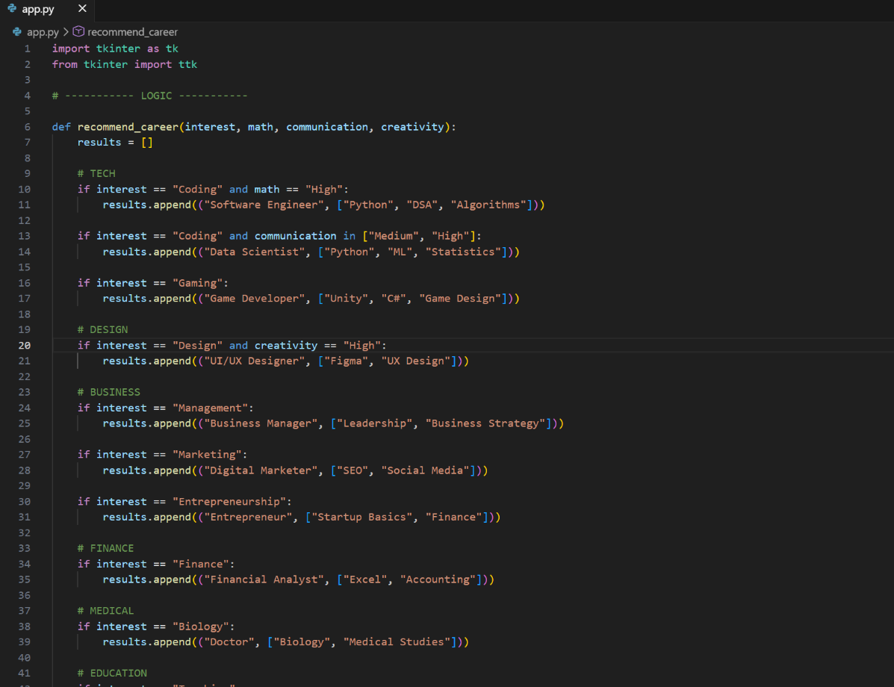
🔹 9. FEATURES
- Modern GUI using Tkinter
- Rule-based AI system
- Supports 15+ interests
- Includes agriculture domain
- Provides course recommendations
- Fast and user-friendly

🔹 10. RESULTS / OUTPUT
The system successfully generates career recommendations.
Example Output:
Career: Software Engineer
Courses:
- Python
- Data Structures
- Algorithms
The GUI displays results clearly and is easy to use.
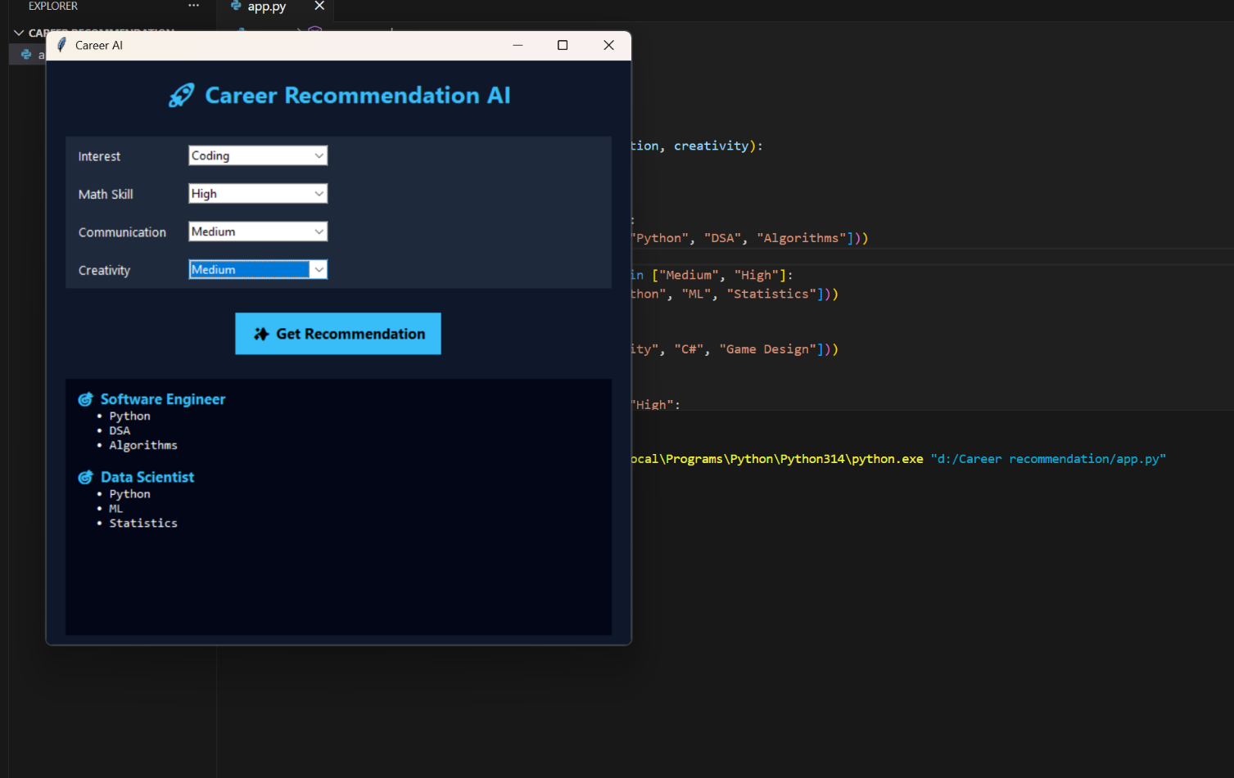

🔹 11. ADVANTAGES
- Easy to use
- Fast decision-making
- Covers multiple domains
- Low cost (no external tools required)
- Transparent logic

🔹 12. LIMITATIONS
- Rule-based (no learning capability)
- Limited to predefined rules
- Not personalized using real data

🔹 13. FUTURE SCOPE
The system can be improved by:
- Adding Machine Learning models
- Creating a web application
- Adding chatbot interface
- Using real-world datasets
- Providing more personalized recommendations

🔹 14. CONCLUSION
This project successfully demonstrates how AI concepts like rule-based systems and knowledge representation can be used to solve real-world problems such as career guidance.
The system provides accurate recommendations based on user inputs and offers a simple yet effective solution for students.

🔹 15. REFERENCES
- Python Official Documentation
- Tkinter Documentation
- AI & Expert System Tutorials
- Online educational resources

